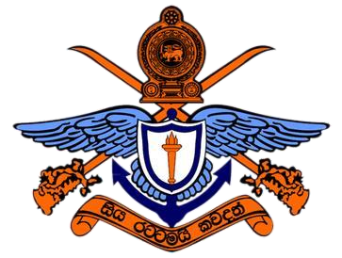
General Sir John Kotelawala Defense University, Sri Lanka Faculty Of Engineering

ET3112 Assignment 02

Student Name : R.M.S.D.Rathnayaka
Registration Number : D/ENG/24/0153/EE
Instructed By : Dr. Sampath Perera
Stream/Intake : Intake 41
Module Code/Name : ET3112-Image Processing and Machine Vision
Date Of Submission : 20.03.2026
Github Link :

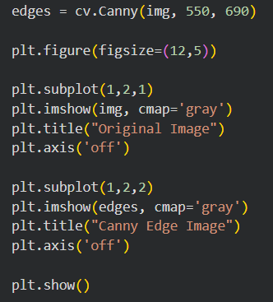
1)

indices = np.where(edges != 0)
x = indices[1]
y = indices[0]

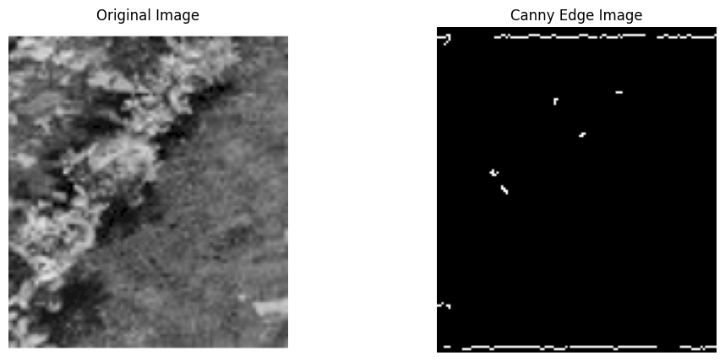

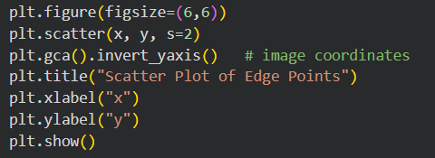
2)

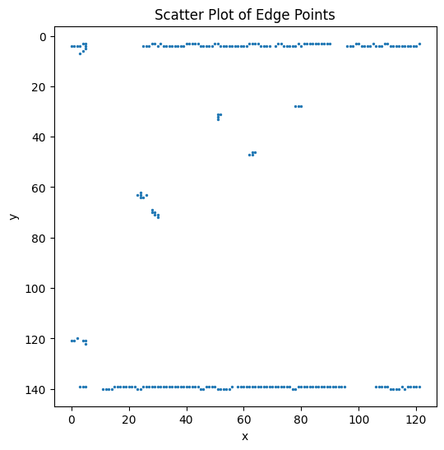

3)
